===SOURCE001===

9 Benefits of Support Groups
by David Susman

Point001
While some groups may have professionals as leaders, many will be led by peers, who are individuals also in recovery. Certain groups are designed to offer support and guidance for the friends and family of persons with mental health concerns.

Point002
Potential Benefits of Support Groups:
1) Realizing you are not alone
2) Expressing your feelings
3) Learning helpful information
4) Improved social skills
5) Gaining hope
6) Reducing distress
7) Increased self-understanding
8) Helping others
9) Affordability

===SOURCE002===
Book Title: Encyclopedia of Community Corrections
Chapter Title: "Addiction-Specific Support Groups"

Point001
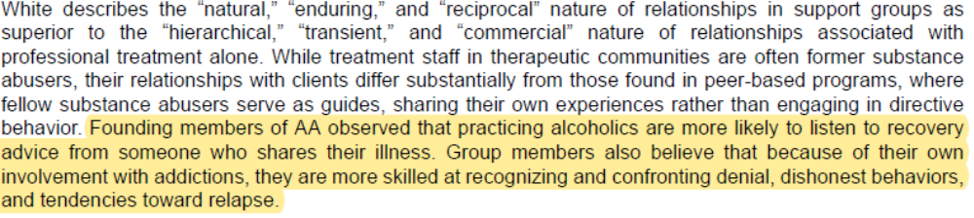

Point002
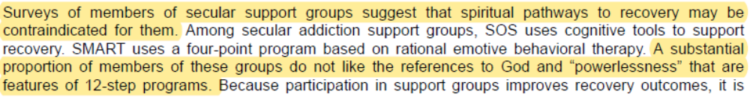

Point003
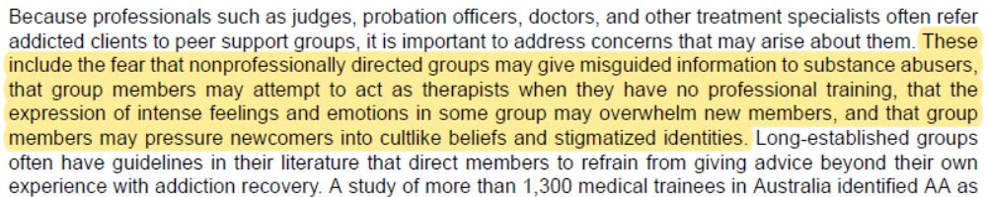

Point004
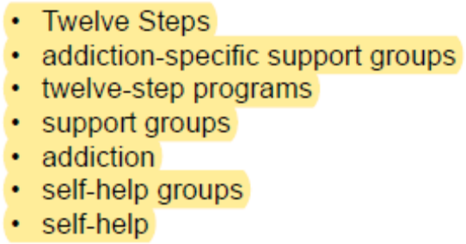

===SOURCE003===

Communicating Social Support in Smartphone-Based Addiction Support Groups: Seeking,

Giving, and Receiving Emotional Support and their Effects on Alcoholism Treatment
By
Woohyun Yoo

Point001

Point002
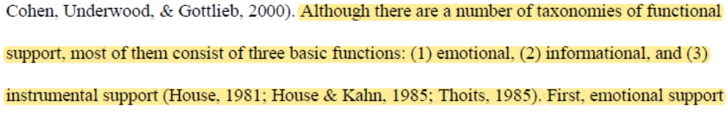


Point003: Social Support - Direct Effects Model


Point004: Social Support - Stress-Buffering Effects Model




Point005: Mutual Aid
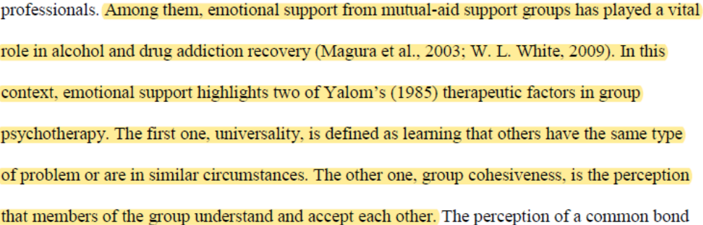



Point006: Writing Down Feelings/Emotions
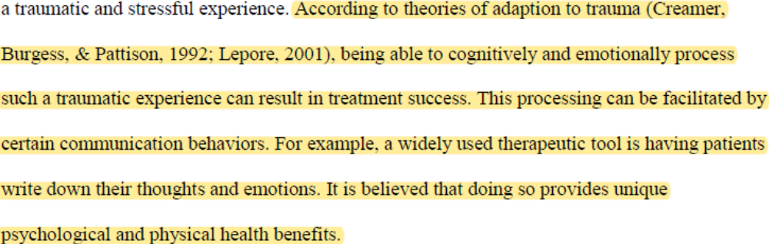


Point007: Computer-Mediated Communication (CMC) and Social Support Exchanges
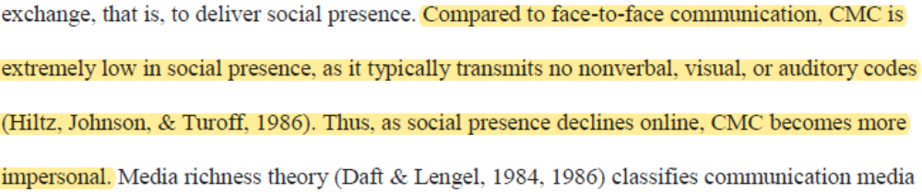

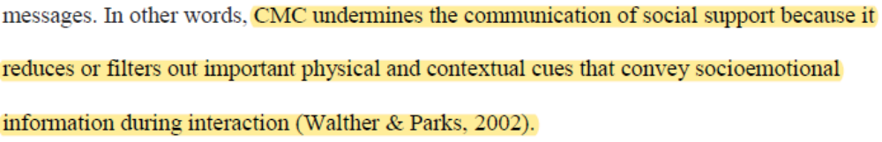

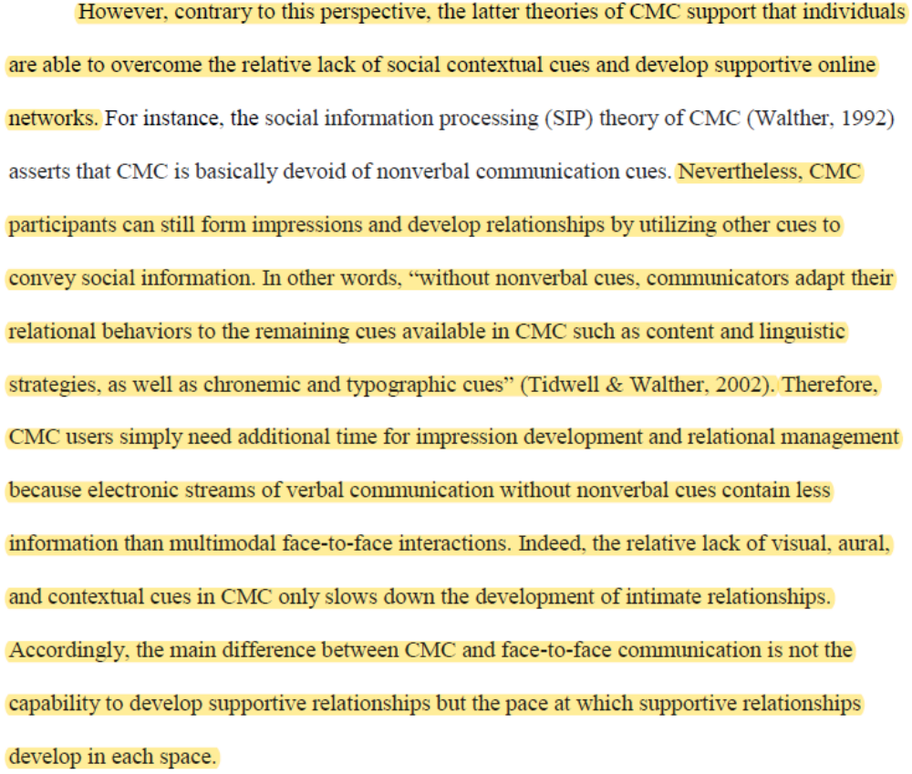





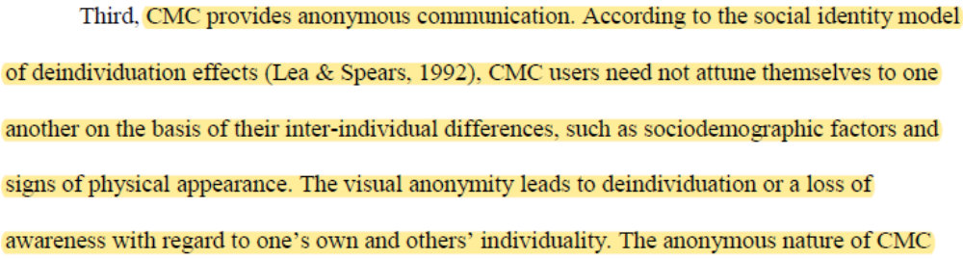


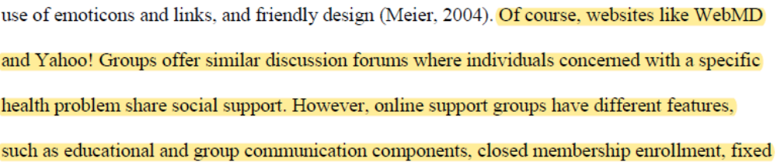

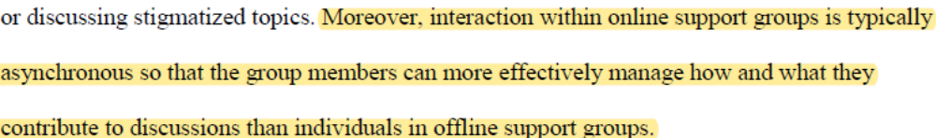



Point008: How Online Support Groups are Used
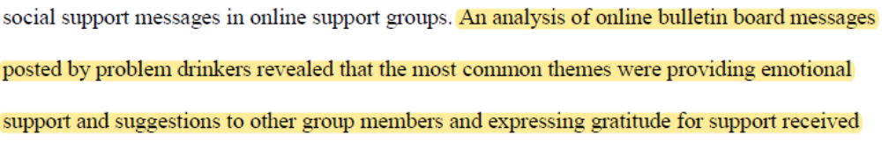
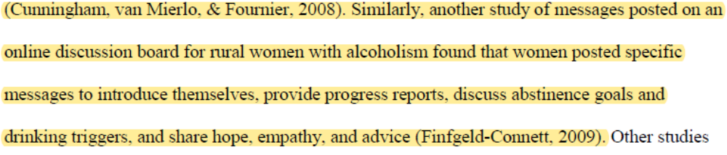

Point009
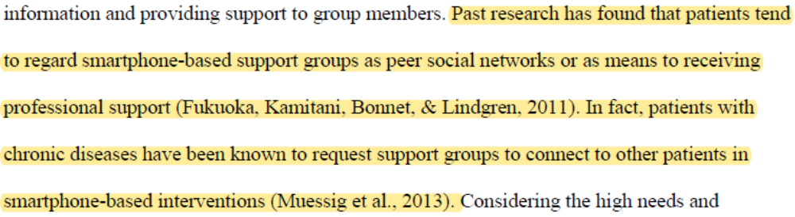

Point010
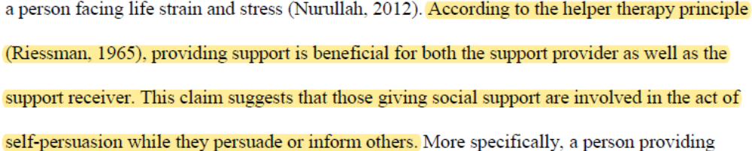

Point011: Risks of Online Support Groups
